OPW Plastic Solutions Returns to Elmia Subcontractor to Showcase Their New Thermoplastic Partnerships & Products
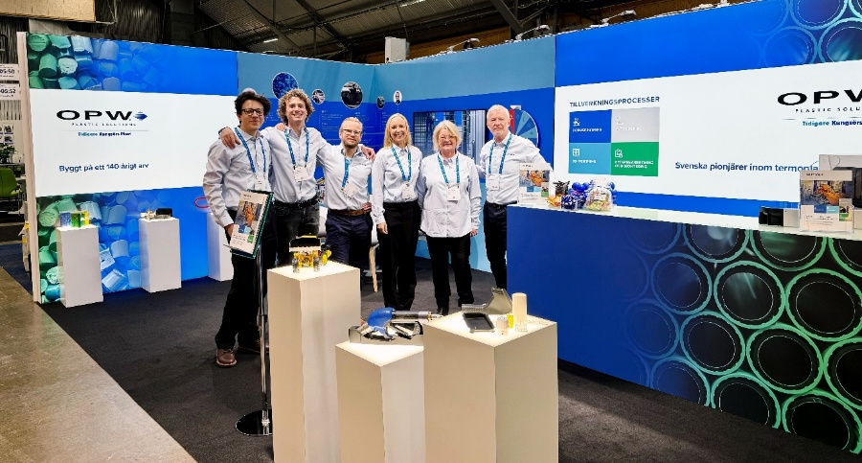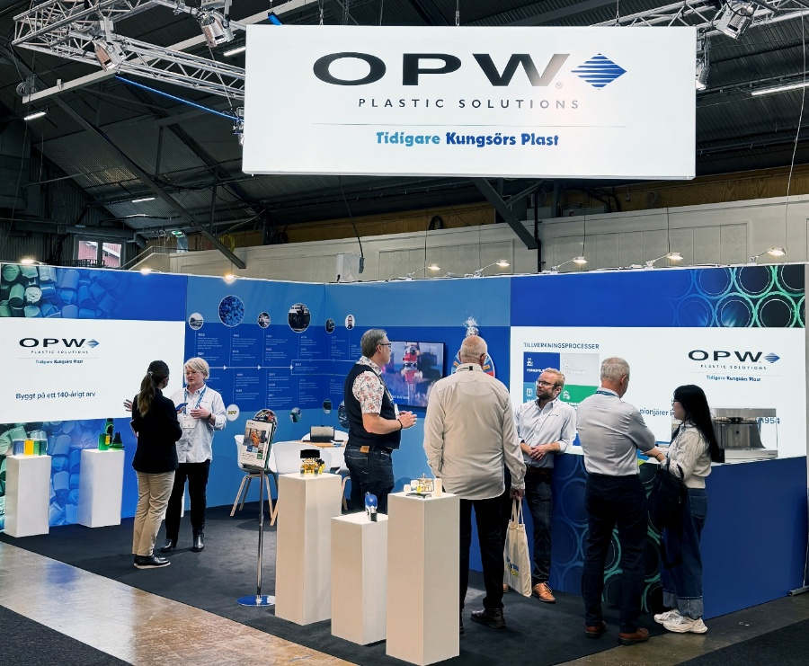
OPW Plastic Solutions’ debut at Elmia Subcontractor 2025

Following a successful debut at Elmia Subcontractor last year, OPW Plastic Solutions will return to Jönköping, Sweden this November (10-12th) with a new stand located at the front of the show in Hall A (Stand A05:18). The new stand includes a huge prize wheel, new partnership products, and the OPW Plastic Solutions thermoplastic experts.
OPW Plastic Solutions are proud of their customer partnerships, some ongoing for 40 years and some which started at Elmia Subcontractor last year. Growing together and supporting each other’s success is key, and these relationships are a testament to this. At this year’s tradeshow OPW Plastic Solutions will be showing some of the products which resulted from these partnerships.
Proudly subcontracting in Sweden for over 140 years and pioneering thermoplastic injection moulding and extrusion since 1954, OPW Plastic Solutions works with partners in myriad industries, including construction equipment, clean energy, energy transfer, and manufacturing equipment and many more to develop and manufacture custom components.
OPW Plastic Solutions invites you to visit them at Elmia Subcontractor on the 10-12th November in Hall A at stand A05:18 to discuss your thermoplastic requirements, explore opportunities to partner to create new components, and spin their new prize wheel!
Register to visit free here: https://www.elmia.se/en/subcontractor/for-visitors/entrance-ticket/

Explore the 2025 stand below with Staffan
https://youtu.be/dJGdufWz894

About OPW Plastic Solutions
Built on a 140 year legacy of Swedish subcontracting, OPW Plastic Solutions provides high-quality bespoke plastic components through thermoplastic injection moulding and extrusion. We also offer assembly, laser marking and 3D (printing) prototyping.
With our support, technical team and manufacturing based in Sweden, we pride ourselves on the personal service and quality we provide to our partners, as supported by our ISO certifications (ISO9001 and ISO14001).
Our best-known product is the KPS piping system, which is specified by major oil companies in over 100 countries. Invented in 1996, we continue to manufacture and develop the system to this day. In the last 5 years, we’ve launched/refined 20 new KPS products, including two completely new product lines: the 3-inch double wall piping system, and the 6-inch double wall piping system. Learn more on the KPS website.
Since 2013, OPW Plastic Solutions (formerly part of Kungsörs Plast) has been a part of OPW (a Dover company), which has supported and accelerated our ongoing innovation and product development.

Contact (EN)
Aaron McConkey
Senior Marketing Manager, OPW
Aaron.mcconkey@opwglobal.com
+44 7854 048 194

